IP Camera

Smartphone -ready colour night/day

network camera with pan, tilt and zoom
DYN-780
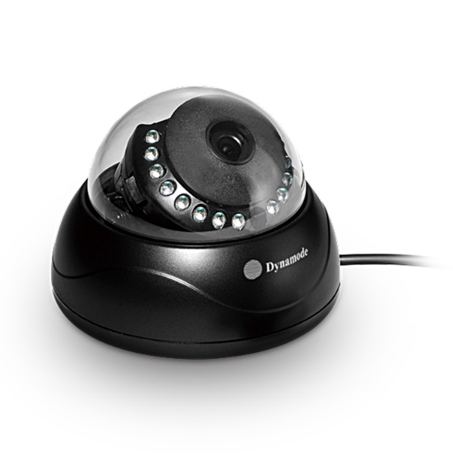

Function and Features
The DYN-780 series is the new H.264 Plug and Play indoor IP Camera. Once you connect IP Camera to internet, no need any setting, you can see anywhere, any place, via manufacturer Mobile phone and PC and tablet software to view what you care for!

Chipset Grain Media 8136S;
P2P, Plug and Play;
1.0 Mega pixels CMOS lens
Support 64G SD card socket for recording storage; build-in 8G TF card, user optional;
Have Widows PC client and Mac pc client.
DYN-780 +Mobile/Tablet/PC +iSmartViewPro =3 steps Install;
Support 3 kinds of H.264 video stream and 1 way MJPEG video stream simultaneously, suitable for Local, Internet and Cross-platform view;
Support resolution for 1280*720/640*360/320*180; 720P HD;
Support 4 ways view in a video stream;
Support 3 times digital zoom;
Support 802.11b/g/n protocol, build-in WiFi module to perform wireless monitoring
IR_CUT, 3.6mm lens;
15pcs IR LED, up to 10 meter night vision;
Built-in web server, use one port to send all the data, users can facilitates network setting;
Support ONVIF and RTSP protocol, easy to integrate it to NVR or large client software;
Support multi-languages web interface, support multi-screen to perform several view at same time;
A free DDNS have been written in device; also support several third party DDNS;
Provide free iSmartViewPro client software, support Multi-view, Long time recording, video replay etc;
Support motion detection.

Introduction
Model | DYN-780
Hardware performance | Product type | IP camera
 | Operation system | Embedded operating system
 | Special function | Support 64G SD/TF card; have Mac PC client.
Web environment | Web protocol | TCP/IP、UDP/IP、HTTP、SMTP、FTP、DHCP、DDNS、UPNP、NTP、RTSP、ONVIF
 | LAN port | 10Base-T/100Base-TX
 | Wifi | WIFI，802.11 b/g/n
Image performance | Resolution | 720P、640*360、320*180
 | Compression mode | H.264/M-JPEG
 | Max frame rate | 30fps
Other parameters | Lens | f=3.6mm, F=2.0
 | Min. illumination | 0 lux
 | Electronic shutter | 1/50s(1/60s)-1/100,000 s
 | SNR | 48db
 | Safety performance | Three levels of user rights
 | Install mode | Ceiling-mounted
 | Other performance | PC software,support for Microsoft Windows 98/2000/XP/Vista/Windows 7/Mac OS,And the Internet Explorer6.0 and above, Firefox,Chrome,Safari etc.,  provide iSmartViewPro client software
 | Power supply | DC 12V
 | Sensor | CMOS Sensor
 | IP camera performance | Support motion detection, external alarm(sends information to alarm the server by Email, FTP);Manufacturers provide free DDNS, and has been written into equipment;  15pcs IR LEDs, 10 meters effectively;  automatically control through the photoresistor;
 | Audio input | None
 | Audio output | None
 | Alarm in | None
 | Alarm out | None
 | Power consumption | Power<8W
Appearance parameters | Body size | Φ105*80mm
 | Product weight | 0.2kg
Environment parameters | Environment temperature | -10℃~50℃
 | Environment humidity | below 85% RH

Packing List
1, IP Camera* 1
2, Driver and tool CD *1
3, Network Cable*1
4, 12V Power Adapter *1

